

**SharePoint: Create Subsite, Use Apps, and Content Type**

Assignment 2

INFO 3250

Feb 20, 2018

LiWen Tan

**Task 1, Create a subsite & apps**

Screen shot 1: subsite “Sales”is created under the site collection

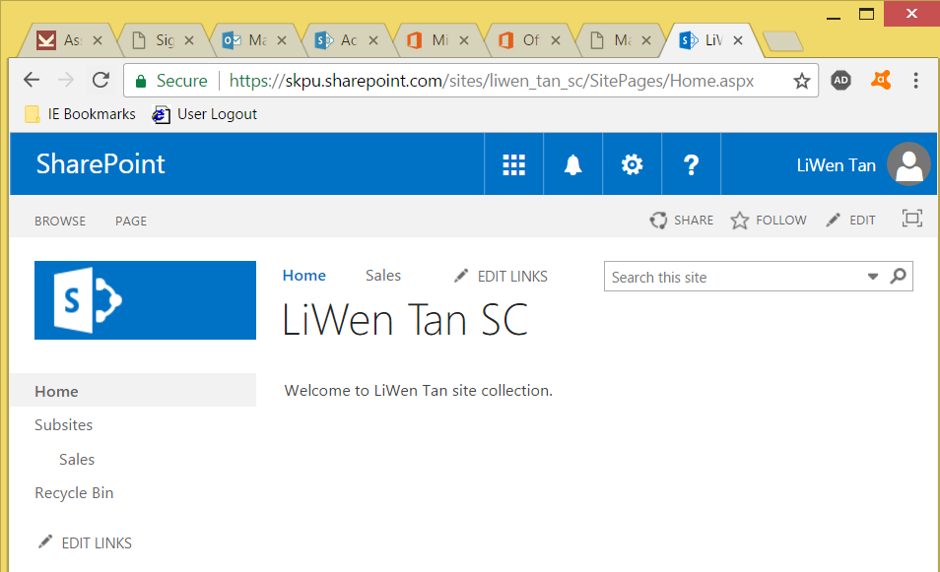

Screen shot 2: Sales subsitewith an announcement app and a new announcement

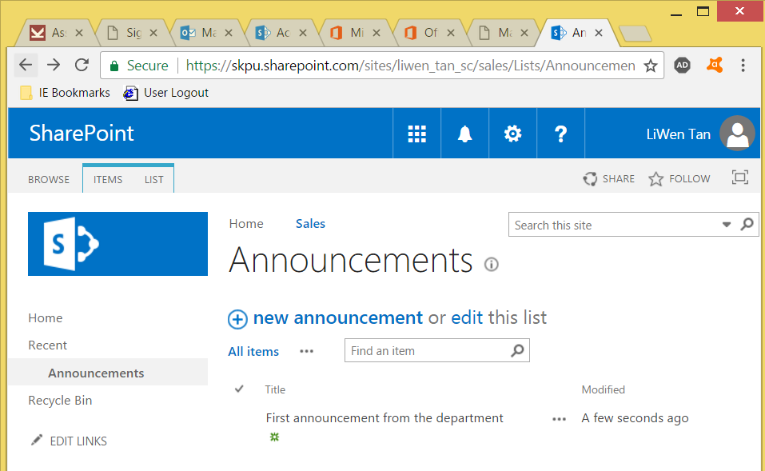

Screenshot 3: Sales subsite with a Calendar app, with 2 new events called “Department Meeting” and “Lunch & Learn” created by the site administrator

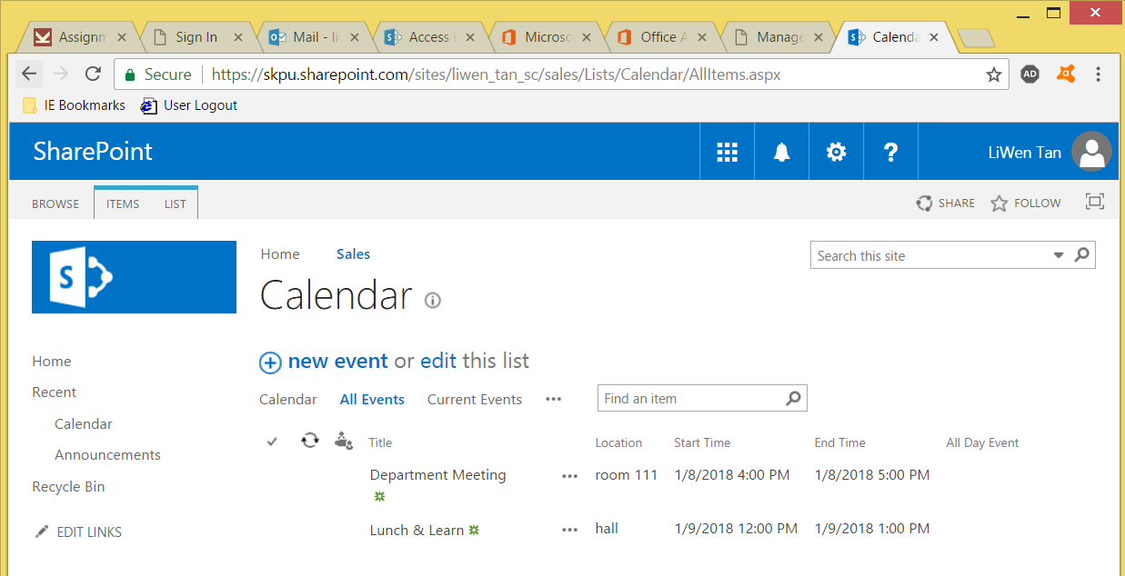

Screenshot 4: The administrator is viewing an event that was created by staffA

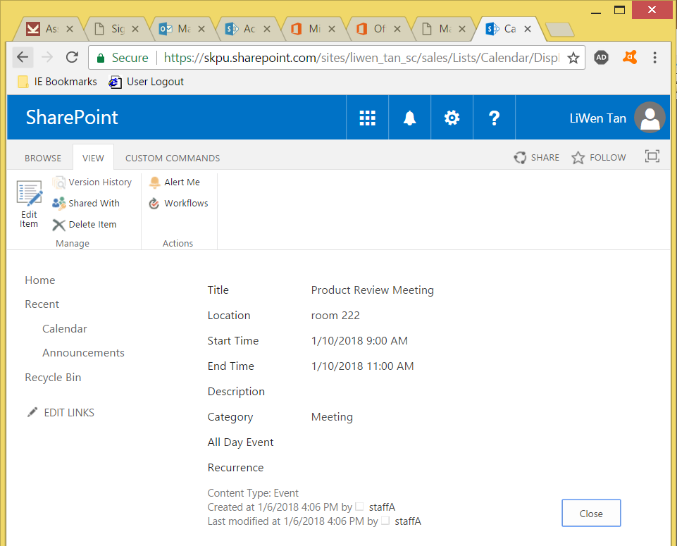

**Task 2, create a content type**

Screenshot 1: A document library named “Contracts” is created in the Sales subsite

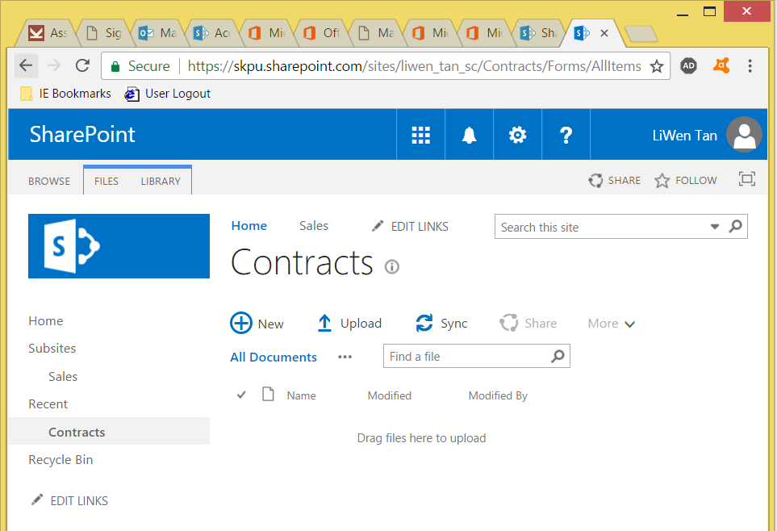

Screenshot 2: A content type named “Contract Doc Type” is created. Content Doc Type has 3 user-defined attributes: starting date, ending date, and sensitivity

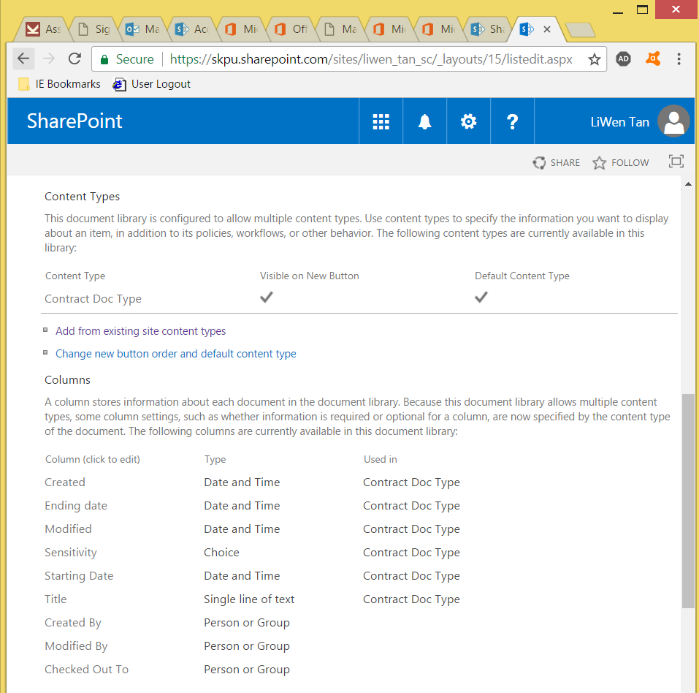

Screenshot 3: A dialogue showing 3 columns (metadata) that are associated with the Contract Doc Type. The dialogue appears every time a document is uploaded using the Contract Doc Type content type.

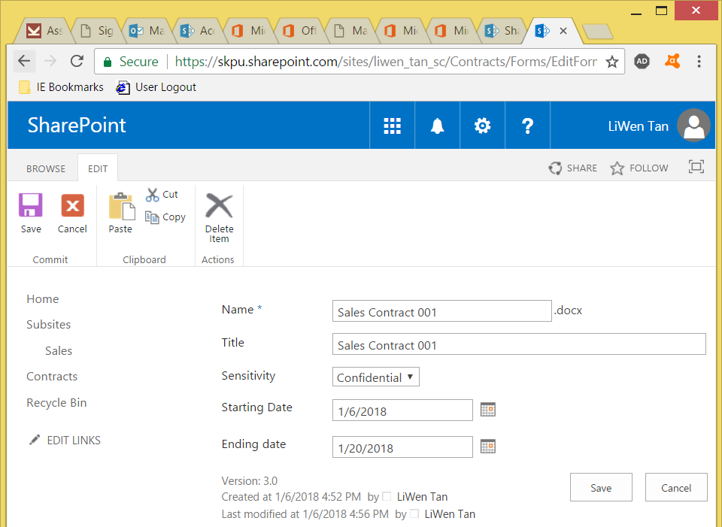

Screenshot 4: Two documents (Sales Contract 001 and 002) are stored in the Contracts library. The 3 content type columns (starting date, ending date, sensitivity) provide more information to the user.

